**HTML, CSS, JS, Bootstrap, Web Development**

# ROOM SEARCH WEBSITE

**A Project Report**

***in partial fulfilment for the award of the degree of***

**Bachelor of Computer Applications**

under

**Engineers Study Centre**



###### ***Submitted by***

**Sujoy Bera** (Roll no. :31001221034)

**Suman Roy** (Roll no. :31001221018)

**Sayan Ghosh** (Roll no. :31001221041)

**Michael Gomes** (Roll no. :31001221039)

**Stream - BCA**

**Meghnad Saha Institute of Technology**

***(Note: All entries of the proforma of approval should be filled up with appropriate and complete information of approval in any respect will be summarily rejected.)***

1. Name of the Student With Group:
   1. **1. Michael Gomes**

**2. Sayan Ghosh**

**3. Sujoy Bera**

**4.Sumon Roy**

1. Title of the Project : **ROOM SEARCH WEBSITE**

3. Name and Address of the Guide : **Mr. Ashraf Ali**

**Engineers Study Centre**

1. Educational Qualification of the Guide : Ph.d* M.tech* B.E*/B.Tech * MCA* M.Sc*



1. Working and Teaching experience

of the Guide**: …………Years**

1. Software used in the Project:
   1. **HTML**
   2. **CSS**
   3. **JavaScript**
   4. **Bootstrap**

1.

2.

3.

4.

5.

--------------------------------------------- ----------------------------------------------------

Signature of the Student Signature of the Guide

Date: Date:

**For Office Use Only Name: Mr. Ashraf Ali** . **Subject Matter Expert.**

Signature, Designation, Stamp of the Project



**Approved Not Approved** Proposal Evaluator

## Project Responsibility Form

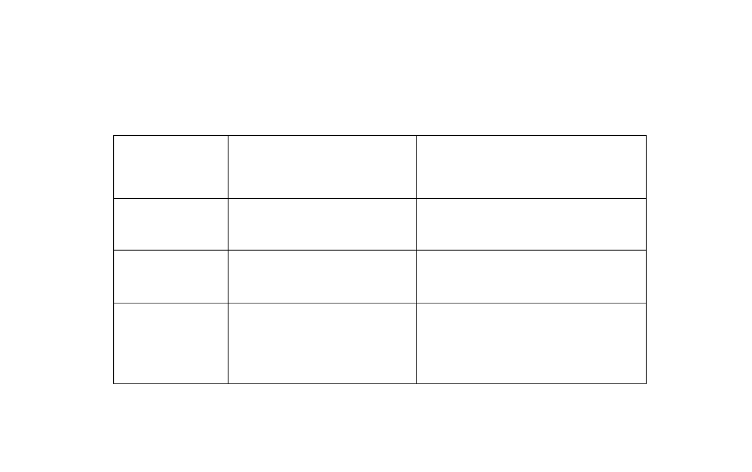

**ROOM SEARCH WEBSITE**

S

ERIAL

NUMBER

NAME

OF MEMBER

RESPONSIBILITY

1

MICHAEL GOMES

PROJECT LEADER AND CODING.

d

Developing

2

SUJOY BERA,

SUMON ROY

WEB PAGE DESIGNING.

3

SAYAN GHOSH

SYSTEM ANALYSIS,

DOCUMENTATION,

POWER POINT



## Self Certificate

This is to certify that the dissertation/project proposal entitled **“ROOM SEARCH WEBSITE”** is done by us, is an Authentic work carried out for the partial fulfilment of the requirements for the award of the certificate of **Bachelor of Computer Application** under the guidance of **Mr. Ashraf Ali**. The matter embodied in this project work has not been submitted earlier for award of any certificate to the best of our knowledge and belief.

**Name of the Student**

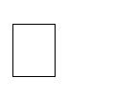 **Michael Gomes**

**Sayan Ghosh**

**Sujoy Bera**

**Suman Roy**

Signature of the students

a.

b.

c.

d.

e.

## Certificate by Guide

This is to certify that this project entitled **“Room Search Website** “submitted in partial fulfilment of the certificate of Bachelor of Computer Application through **Engineers Study Centre**

, done by the Group Members

**Michael Gomes**

**Sayan Ghosh**

 **Sujoy Bera**

**Suman Roy**

is an authentic work carried out under my guidance & best of our knowledge and belief...

a.

b.



c.

d.

e.

Signature of the students Signature of the Guide

Date: Date:

### Certificate of Approval

This is to certify that this proposal of Minor project, entitled “**Room Search Website**” is a record of bona-fide work, carried out by: **1. Sujoy Bera, 2. Suman Roy, 3. Sayan Ghosh, 4. Michael Gomes** under my supervision and guidance through **Engineers Study Centre** In my opinion, the report in its present form is in partial fulfilment of all the requirements, as specified by the **Meghnad Saha Institute of Technology** as per regulations of the **Engineers Study Centre®**. In fact, it has attained the standard, necessary for submission. To the best of my knowledge, the results embodied in this report, are original in nature and worthy of incorporation in the present version of the report for **Bachelor of Computer Application**.

Guide/Supervisor

**_____________________________________________________________**

**Mr. Ashraf Ali**

**Engineers Study Centre**

_______________________ ____________________________

**External Examiner (s) Head of the Department**

Department of Computer Application

**Kolkata, W.B**

**(Affiliated to MAKAUT, WB)**